Use Case Diagrams for Invoice Generating System

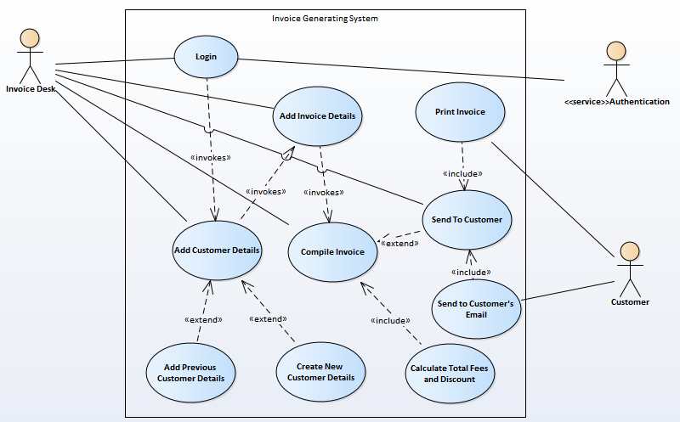

|  |  |  |  |  |  |  |
| --- | --- | --- | --- | --- | --- | --- |
| Use Case Name: Login | | | ID – UC-1 | | Priority: High | |
| Actor: Invoice Desk | | | | | | |
| Description: This use case describes how the Invoice Desk or staff will need login information to be able to access the Invoice generation system | | | | | | |
| Trigger: Invoice desk decides to generate a new invoice  Type: _ External _ Temporal | | | | | | |
| Preconditions:   1. Must want to create a new invoice 2. Must have log in information 3. Must also have necessary invoice details | | | | | | |
| Normal Course:   1. Invoice Desk passes in Username 2. Invoice Desk passes in Password 3. Invoice Desk submits Username and password 4. Authentication is then carried out 5. If authentication is accepted, Invoice Desk would be granted access to the system 6. If authentication is not accepted, the Invoice Desk would have to try again (for a certified number of times before access to system is denied). | | | | Information for Steps:  Username  Password  Authentication  Authentication Complete  Access Approved  Access Denied | | |
| Post Conditions:   1. If Authentication is complete, the Invoice desk is given access to the Add Customer Details UC | | | | | | |
| Summary Source Outputs Destination  Inputs | | | | | | |
| Username  Password | Invoice Desk  Invoice Desk | Access allowed or denied | | | | Authentication  Authentication |

|  |  |  |  |  |  |  |
| --- | --- | --- | --- | --- | --- | --- |
| Use Case Name: Add Customer Details | | | ID – UC- 2 | | Priority: High | |
| Actor: Invoice Desk | | | | | | |
| Description: This is used to enter the customer information who the invoice is for | | | | | | |
| Trigger: Access allowed from the Login  Type: _ External _ Temporal | | | | | | |
| Preconditions:   1. The invoice desk can either add an already existing customer information or fill in the form for a new customer 2. There is a customer data store | | | | | | |
| Normal Course:   1. If the customer already exists, the Invoice Desk queries the data store for the id of the customer and the customer is added and the UC ends here. (Extends Sub Use Case Add Previous Customer Details) 2. If the customer does not exist, the Invoice Desk fills the Customer Details form, provided by the system which includes: 3. Id 4. Title 5. First Name 6. Last Name 7. Address 8. Phone Number 9. Package   (Extends Sub Use Case Create New Customer Details) | | | | Information for Steps:  Data store  Data store | | |
| Post Conditions:   1. New customer Information is stored in the customer database 2. Completion of this UC will lead the Invoice Desk to UC-3 | | | | | | |
| Summary Source Outputs Destination  Inputs | | | | | | |
| Customer Details | Invoice Desk | Customer Details | | | | Invoice Desk |

|  |  |  |  |  |  |  |
| --- | --- | --- | --- | --- | --- | --- |
| Use Case Name: Add Invoice Details | | | ID – UC-3 | | Priority: High | |
| Actor: Invoice Desk | | | | | | |
| Description: This is used to enter the invoice information who the invoice is for | | | | | | |
| Trigger: UC2 is completed  Type: _ External _ Temporal | | | | | | |
| Preconditions:   1. All information about the Invoice are ready for the form 2. There is an Invoice data store 3. Items are passed in the right format | | | | | | |
| Normal Course:   1. The Invoice Desk fills the Invoice Details form provided by the system which includes: 2. Car Rental Name 3. Invoice Number 4. Invoice Date 5. Car Number 6. Car Make 7. Kilometres/Hour 8. Duration (Hours) 9. Rent/Hour 10. Initial Amount Paid 11. Total Duration 12. Discount 13. Total 14. Amount Due 15. Signature of Owner 16. Signature of Customer | | | | Information for Steps:  Data Store | | |
| Post Conditions:   1. Invoice Data is stored in the Data Store 2. Completion of this UC will lead the Invoice Desk to UC-4 | | | | | | |
| Summary Source Outputs Destination  Inputs | | | | | | |
| Invoice Information | Invoice Desk |  | | | |  |

|  |  |  |  |  |  |  |
| --- | --- | --- | --- | --- | --- | --- |
| Use Case Name: Compile Invoice | | | ID – UC-4 | | Priority: High | |
| Actor: Invoice Desk | | | | | | |
| Description: This is where the invoice is packaged for the final entity, the Customer | | | | | | |
| Trigger: Invoice Desk fills up the Invoice Details form and submits  Type: _ External _ Temporal | | | | | | |
| Preconditions:   1. All information from customer and invoice is compiled | | | | | | |
| Normal Course:   1. The Customer Information and the Invoice information is arranged step by step or symmetrically in form of an invoice. 2. The various fees are calculated and new fees are slotted in appropriately 3. If there is a discount, this discount is taken into consideration here. | | | | Information for Steps:  Data Store  Process  Process | | |
| Post Conditions:   1. The invoice is hereby ready for the customer and is saved in the data store | | | | | | |
| Summary Source Outputs Destination  Inputs | | | | | | |
| Fees  Discount | Invoice Desk  Invoice Desk | Invoice | | | | Customer |

|  |  |  |  |  |  |  |
| --- | --- | --- | --- | --- | --- | --- |
| Use Case Name: Send to Customer | | | ID – UC-5 | | Priority: Medium | |
| Actor: Invoice Desk | | | | | | |
| Description: This is used to send the invoice to the customer, either by soft or hard copy | | | | | | |
| Trigger: Invoice desk wishes to send a copy of the invoice to the Customer  Type: _ External _ Temporal | | | | | | |
| Preconditions:   1. Invoice must be ready to be sent | | | | | | |
| Normal Course:   1. If the Invoice Desk wants to print the invoice, they send the invoice to the printer 2. If the Invoice Desk wants to send the invoice to the Customer’s email, the send it. | | | | Information for Steps:  External service | | |
| Post Conditions: | | | | | | |
| Summary Source Outputs Destination  Inputs | | | | | | |
|  |  | Invoice | | | | Customer |